Simon

# Basic Game Idea

In simon the game will play a sequence of notes (set of 4) while highlighting a colour in a sequence getting one note bigger each iteration. After the sequence has been played the user needs to enter the same notes(colours) in the correct order within a specified time. We will have 3 levels of difficulty 8 notes / 16 notes / 32 notes

# Game Mechanics

Alternating between demonstrate and receive after every new note added to the sequence. Each note should be a (chord/octave ?? whatever higher, same sound different pitch). When playing the notes the corresponding button should light up for a period of time (½ second) and then return to normal. The gap between notes should decrease as the sequence gets longer. The sequence of notes should be random and change every game.

# User Interface

Game will have 4 modes

1. Menu
2. Demonstrate
3. Receive
4. Game over

## Menu

In this mode we will use the four coloured buttons to allow the user to choose the level of difficulty. Green for easy, red for medium and yellow for hard.

Blue will exit the game. The text describing the buttons actions will be displayed on the left of the screen in the corresponding colour.

## Demonstrate

Play the notes pausing ½ second between notes, this time to decrease as the sequence increases 1/30 of a second (need to edit rate of change so it slow as values diminish perhaps try percentage decrease 4%). The button should also light up for the same (or perhaps longer period: longer than duration of note), might be nice to fade back but also might not work for game reasons. Don't display button text and do display status text on bottom right to indicate that computer has control. “Showing”

## Receive

In this mode set status text to “Listening” play the corresponding note and highlight the button when the user clicks( releases) the button. If they get the note wrong or take too long (1 second after first note, 2 seconds for first note) then goto game over mode loosing. If they complete the sequence check if the game is won 8 note on easy , 16 notes on medium and 32 notes on hard, if so then got game over mode winning else go back to demonstrate mode and add another note to the sequence.

## Game Over

Play the lowest note five times if they lose and then after 3 seconds goto the menu. Play two alternating notes 3 times each if they win and go to the menu. Display the text “Game Over” in the status area.

# Art

Sample screenshot. Four buttons won’t be contoured in the basic game and will have a solid colour. Raise the colour values by 25% when highlighting. Outer margin should be 50% thicker than interbox spacing.

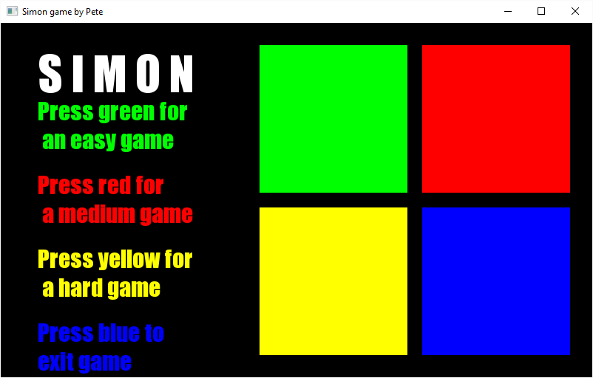

# Audio

Use the same tone and change the pitch up or down. Perhaps a sine wave.